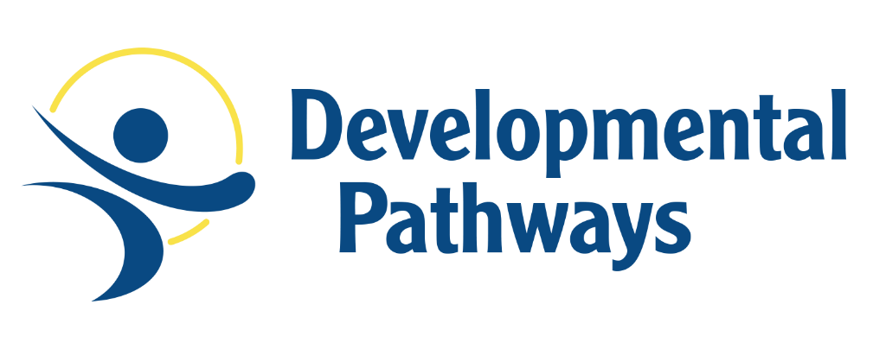
Gift Acceptance Policy
Developmental Pathways is required to follow federal, state and board approved state rules and regulation regarding charitable contributions.

Developmental Pathways must determine if a gift meets the criteria for acceptance. In general, a charitable contribution is a gift that has three essential elements: donative intent, delivery and acceptance. The following outlines the general rules that we must consider in order to accept a gift.

Donations will generally be accepted from individuals, partnerships, corporations, foundations, government agencies, or other entities.

In the course of its regular fundraising activities, Developmental Pathways will accept donations of money, personal property and in-kind goods and services. The In-kind Gift Donation Form is to be completed by the donor and the employee accepting the donation.

Gifts of real property, personal property, life insurance or securities may only be accepted upon approval of the Gift Acceptance Committee.

Assessment on Charitable Gifts
Developmental Pathways gift assessment is 7% and is applied evenly to all charitable gifts. The fee does not cover all of our operational costs, but the fees are one of several sources of funding and are reinvested in the critical fundraising operations. There are no additional fees applied at the time of the expenditure of the gifts. Should a donor’s policy disallow administration expense, the potential gift will be reviewed by the Gift Acceptance Committee.

We are proud that 93% of every dollar given is directed to the specific purpose for which it is given. We strive to keep costs down and return on the investment high for the individuals we support.

Developmental Pathways will seek the advice of legal counsel in matters relating to acceptance of gifts when appropriate. Developmental Pathways shall encourage donors to seek independent professional counsel to represent the donor’s interests and to explore the alternatives, costs, tax benefits and obligations of potential gifts.

